had an opportunity recently to design a Bayesian adaptive trial with several interim analyses that allow for early stopping due to efficacy or futility. The code below implements the one-arm trial .Three of the coauthors are current or former colleagues at Vandy. The figures below the code show the sample size distribution under the null hypothesis and an alternative hypothesis, respectively.

## Simulate Bayesian single-arm adaptive trial

## Allow early termination due to futility or efficacy

## Binary outcome

## Beta-binomial:

## p ~ beta(a, b)

## x_i ~ binomial(p) i = 1..n

## p|x ~ beta(a + sum(x), b + n - sum(x))

## Efficacy at interim t if Pr(p > p_0 | x_{(t)}) > \gamma_e

## Futility at interim t if Pr(p > p_0 | x_{(t_max)}) < \gamma_f

## https://www.ncbi.nlm.nih.gov/pmc/articles/PMC4247348/

library('rmutil') ## for betabinom

## Simulate entire trial

## ptru - true probability of outcome (p)

## pref - reference probability of outcome (p_0)

## nint - sample sizes at which to conduct interim analyses

## efft - efficacy threshold

## futt - futility threshold

## apri - prior beta parameter \alpha

## bpri - prior beta parameter \beta

simtrial <- function(

ptru = 0.15,

pref = 0.15,

nint = c(10, 13, 16, 19),

efft = 0.95,

futt = 0.05,

apri = 1,

bpri = 1) {

## determine minimum number of 'successes' necessary to

## conclude efficacy if study continues to maximum

## sample size

nmax <- max(nint)

post <- sapply(0:nmax, function(nevt)

1-pbeta(pref, apri + nevt, bpri + nmax - nevt))

nsuc <- min(which(post > efft)-1)

## simulate samples

samp <- rbinom(n = nmax, size = 1, prob = ptru)

## simulate interim analyses

intr <- lapply(nint, function(ncur) {

## compute number of current events

ecur <- sum(samp[1:ncur])

## compute posterior beta parameters

abb <- apri + ecur

bbb <- bpri + ncur - ecur

sbb <- abb + bbb

mbb <- abb/(abb+bbb)

## compute efficacy Pr(p > p_0 | x_{(t)})

effp <- 1-pbeta(pref, abb, bbb)

## return for efficacy

if(effp > efft)

return(list(action='stop',

reason='efficacy',

n = ncur))

## number of events necessary in remainder of

## study to conclude efficacy

erem <- nsuc-ecur

## compute success probability Pr(p > p_0 | x_{(t_max)})

if(erem > nmax-ncur) { ## not enough possible events

sucp <- 0

} else { ## not yet met efficacy threshold

sucp <- 1-pbetabinom(q = erem-1,

size = nmax-ncur, m = mbb, s = sbb)

}

if(sucp < futt)

return(list(action='stop',

reason='futility',

n = ncur))

return(list(action='continue',

reason='',

n = ncur))

})

stpi <- match('stop', sapply(intr, `[[`, 'action'))

return(intr[[stpi]])

}

## Simulate study with max sample size of 200 where true

## probability is identical to reference (i.e., the null

## hypothesis is true). This type of simulation helps us

## determine the overall type-I error rate.

nint <- c(40,80,120,160,200)

nmax <- max(nint)

res <- do.call(rbind, lapply(1:10000,

function(t) as.data.frame(simtrial(ptru = 0.72,

pref = 0.72,

nint = nint,

efft = 0.975,

futt = 0.20))))

## Prob. early termination (PET) due to Futility

mean(res$reason == 'futility' & res$n < nmax)

## PET Efficacy

mean(res$reason == 'efficacy' & res$n < nmax)

## Pr(conclude efficacy) 'type-I error rate'

mean(res$reason == 'efficacy')

## average and sd sample size

mean(res$n); sd(res$n)

barplot(prop.table(table(res$n)),

xlab='Study Size (N)',

main="No Difference")

## Simulate study where true probability is greater than

## reference (i.e., an alternative hypothesis). This type

## of simulation helps us determine the study power.

res <- do.call(rbind, lapply(1:10000,

function(t) as.data.frame(simtrial(ptru = 0.82,

pref = 0.72,

nint = nint,

efft = 0.975,

futt = 0.20))))

## Prob. early termination (PET) due to Futility

mean(res$reason == 'futility' & res$n < nmax)

## PET Efficacy

mean(res$reason == 'efficacy' & res$n < nmax)

## Pr(conclude efficacy) 'power'

mean(res$reason == 'efficacy')

## average and sd sample size

mean(res$n); sd(res$n)

barplot(prop.table(table(res$n)),

xlab='Study Size (N)',

main="35% Reduction")

[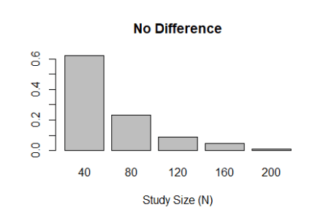](https://i0.wp.com/biostatmatt.com/uploads/null.png)

[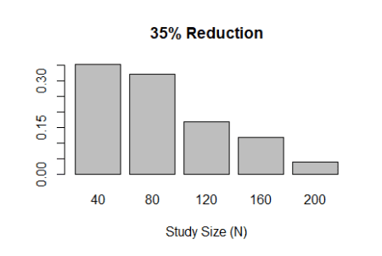](https://i2.wp.com/biostatmatt.com/uploads/alt.png)